Improving Health and Well-being in the
District of Hope and Communities of the Fraser Canyon

Macro Health Grant 2024
Application Package

Overview
- One Macro Health Grant of $25,000 (maximum) is available to support a community-based project to improve health and well-being in the District of Hope and Communities of the Fraser Canyon
- Macro Health Grant applications will be evaluated through a set of guiding principles and eligibility criteria, including partnership and sustainability
- Important features of a Macro Health Grant initiative are greater community impact, fostering partnerships and using this Grant as a leverage to generate bigger opportunities that can continue over time, encourage expansions of activities and seek possible future funding opportunities (for example, the bus transit initiative or the master plan development for active transportation to apply for provincial grants; or use this investment as the catalyst to launch a new sustainable program or service)
- Macro Health Grant applications are due Friday, October 11, 2024
- For more information and to apply, please see details in this application package

1.0 Introduction

Fraser Health is investing $500,000 dollars on an ongoing basis to collaborate with the District of Hope and Communities of the Fraser Canyon (including Boston Bar) to improve overall health and well-being of residents residing in these communities. The funding is in place to support community based actions and strategies that are directed at improving health outcomes for all residents in these communities. These health outcomes include and are not limited to decreases in chronic disease rates, improved rates of physical activity and consumption of healthy foods, reduction in smoking, and improvements in mental health and substance use outcomes through the reduction of depression and suicide in the community.
2.0 Objectives
Of the $500,000 of funding, $25,000 is designated to support one Macro Health Grant for one time funding allocated towards a project that would give the community the opportunity to invest in the overall health of the community. The maximum funding available is $25,000. The Macro Health Grant will be evaluated by the Hope and Area Healthy Communities Committee and the Steering Committee through a set of guiding principles.
• Achievability | • Sustainability | • Affordability
• Partnership | • Measurability | • Accessibility/Health Equity
• Impact | • Social Change | • Safety

Important features of a Macro Health Grant initiative are greater community impact, fostering partnerships and using this Grant as a leverage to generate bigger opportunities that can continue over time, encourage expansions of activities and seek possible future funding opportunities (for example, the bus transit initiative or the master plan development for active transportation to apply for provincial grants; or use this investment as the catalyst to launch a new sustainable program or service).
Objectives of the Macro Health Grant are to enhance the following areas:
- Improve health and well-being throughout the District of Hope and Communities of the Fraser Canyon
- Promote actions and strategies that support improvement in population health
- Promote community inclusion and involvement through a health equity lens
- Create greater awareness around health promotion and education
- Improve and increase community partnerships with and amongst community groups and Fraser Health
For the 2024-2025 grant year, we are also accepting applications to promote community pandemic recovery such as:
- Building resilience, mental health promotion
- Initiatives aimed at strengthening emergency preparedness at an organization or neighbourhood level
- Initiatives that leverage technology to support alternative program/service delivery

3.0 Eligibility Criteria

- Eligibility Criteria

ACTIVITIES
Successful Macro Health Grant applications will have to adhere to at least one of the following criteria in utilizing the funding:
- Significant transformation of an existing service or program (improving access, transportation, education, housing)
- New or innovative service or program that meets an identified need
- Leveraging opportunities for a greater return (for example, utilizing the learnings and activities of the Macro Health Grant initiative to apply for future funding opportunities)
- Supporting greatest impact for the population at large
- Supporting transformative opportunities to improve the reach/scope from Hope including communities of the Fraser Canyon
APPLICANTS

Eligible applicants are:
- organizations or individuals with demonstrated partnership:
  - non-profits, government agencies, private sector, First Nations Communities, School District, Fraser Valley Regional District, and others
- located in or provide service to the geographic region of Hope and the Fraser Canyon (Electoral Areas A and B)

- Ineligible Funding Activities

The list below lists examples and potential ineligible funding activities:
- Duplication of programs/services
- Increases to costs or new costs for program/service utilization/staff wages
- Significant equipment/material purchases for individual and/or organizational need
- Investment into IT services/resources for organization
- Office lease payment

4.0 Application Instructions

Step 1 Review Introduction, Objectives, and Eligibility Criteria (Sections 1-3)
Step 2 Complete all sections of the Macro Health Grant application form
Step 3 Acquire (minimum) one letter of support describing partnership and endorsing your project to improve health and well-being in the community
Step 4 Submit completed application form and letter(s) of support to
fhhopegrants@gmail.com
Deadline: Friday, October 11, 2024, 11:59 pm

Questions? Please contact fhhopegrants@gmail.com

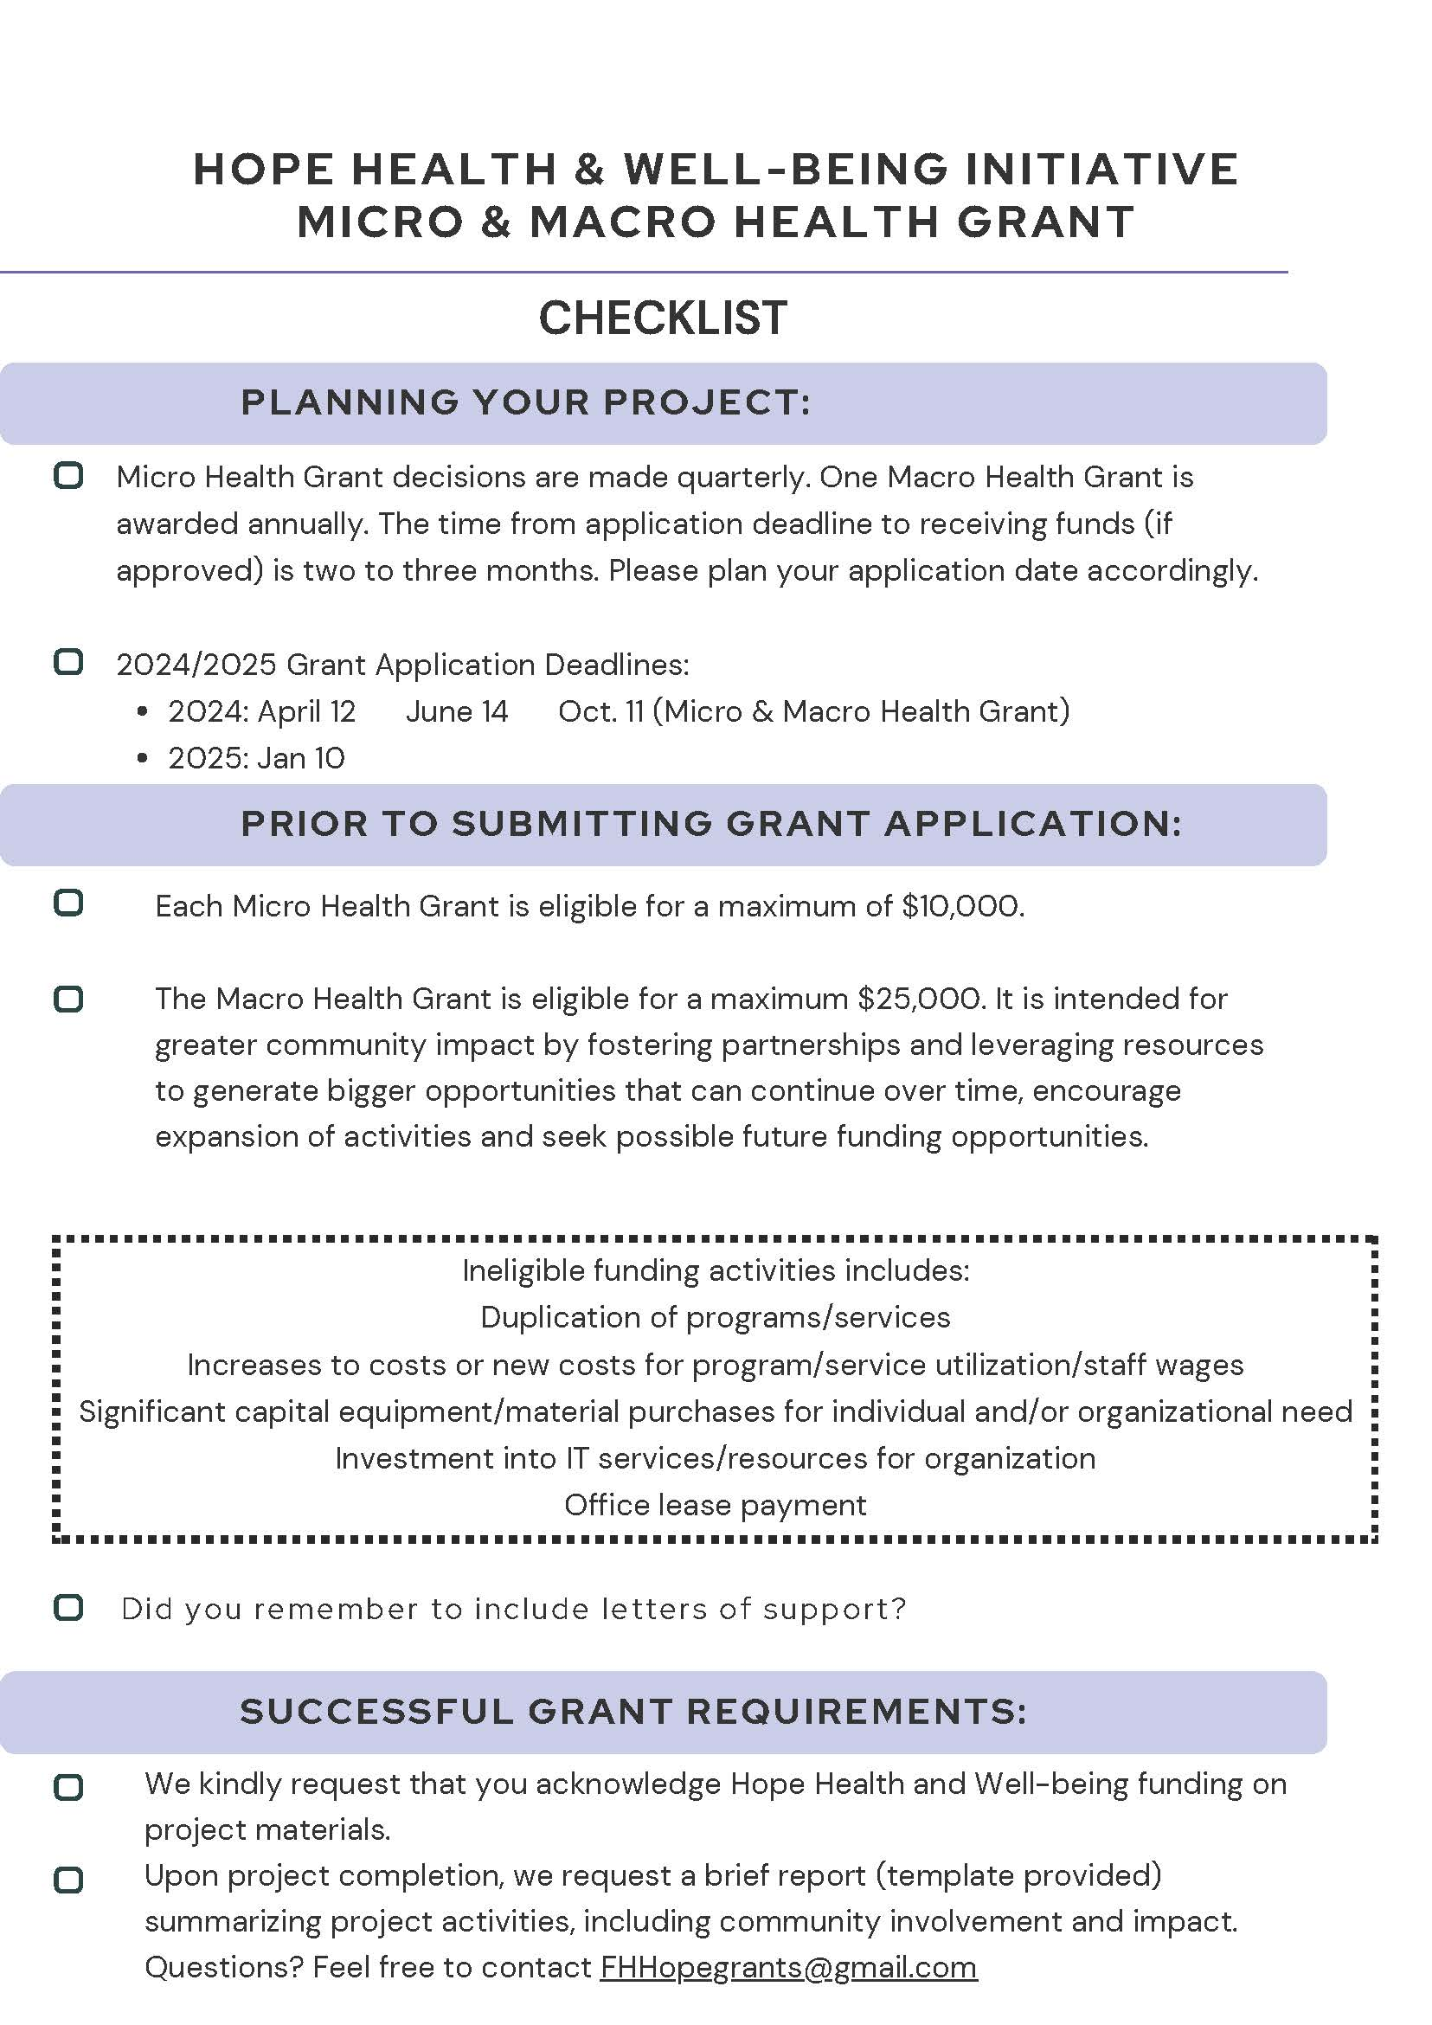

5.0 Application Form
Macro Health Grant Title: |  | Organization Name:
Applicant(s) Name, Position: |  | Mailing Address:
Phone: |  | Email:
Total Requested  (maximum $25,000): | Target Audience: |  | Estimated Reach:
If successful, make cheque payable to:
Project Description & Objectives (limit 500 words):

Confirmed Partners:

Intended Outcomes, Measurables/Indicators & Impact:

Sustainability:
(describe how you have considered sustainability such that the initiative is a catalyst for activities that continue over time)

Detailed Budget:
(detailed budget line items, and if applicable attach quotes and estimates)

Applicant Commitment:
(describe the Applicant’s financial commitment (cash and/or in-kind) to the initiative, and ideas for pursuing future funding support)

