Improving Health and Well-being in the District of Hope and Communities of the Fraser Canyon
Micro Health Grant Application
2024-2025

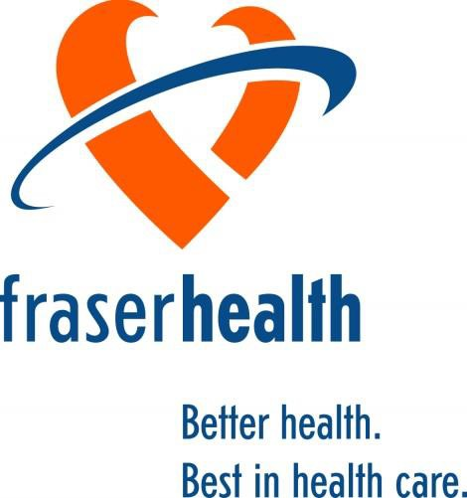

1.0 Introduction
Fraser Health is investing $500,000 dollars on an ongoing basis to collaborate with the District of Hope and Communities of the Fraser Canyon (including Boston Bar) to improve overall health and well-being of residents residing in these communities. The funding will be in place to support community-based actions and strategies that are directed at improving health outcomes for all residents in these communities. These health outcomes include and are not limited to decreases in chronic disease rates, improved rates of physical activity and consumption of healthy foods, reduction in smoking and improvements in mental health and substance use outcomes through the reduction of depression and suicide in the community.

Micro Health Grants Objectives and Eligibility

Annually $50,000 is designated to support the Micro Health Grants for one time funding allocated towards projects that would give the community the opportunity to invest in the overall health of the community (such as children’s playgrounds, train the trainer programs, after school programs). Each Micro Health Grant is eligible for a maximum of $10,000 each. All Micro
Health Grants will be evaluated by the Hope and Area Healthy Communities Committee and the Hope Health and Wellbeing Initiative Steering Committee through a set of guiding principles:

- Achievability | - Sustainability | - Affordability
- Partnership | - Measurability | - Accessibility
- Impact | - Social Change | - Safety

Objectives of the Micro Health Grant are to enhance the following areas:
    - Improve health and well-being throughout the District of Hope and Communities of the Fraser Canyon
    - Promote actions and strategies that support improvement in population health
    - Promote community inclusion and involvement through a health equity lens
    - Create greater awareness around health promotion and education
    - Improve and increase community partnerships with and amongst community groups and Fraser Health

Eligible Funding Activities
Successful Micro Health Grant applications will have to adhere to the following criteria in utilizing the funding.
  - Providing or redesigning an enhanced service (improving access, transportation, education)
  - Improving awareness of a program/service
  - Initiatives that support quality improvement of a particular program/service
  - Supporting the reach/scope from Hope including communities of the Fraser Canyon
  - Supporting infrastructure or healthy built environment including purchase of small equipment
For the 2024-2025 grant year, we are also accepting applications to promote community post-pandemic recovery such as:
- Building resilience, mental health promotion
- Initiatives aimed at strengthening emergency preparedness at an organization or neighbourhood level
- Initiatives that leverage technology to support alternative program/service delivery

Ineligible Funding Activities
The list below lists examples and potential ineligible funding activities:
  - Duplication of programs/services
  - Increases to costs or new costs for program/service utilization/staff wages
  - Significant capital equipment/material purchases for individual and/or organizational need
  - Investment into IT services/resources for organization
  - Office lease payment
Grant decisions are made quarterly. The time from application deadline to receiving funds (if approved) is two – three months. Please plan your application date accordingly.

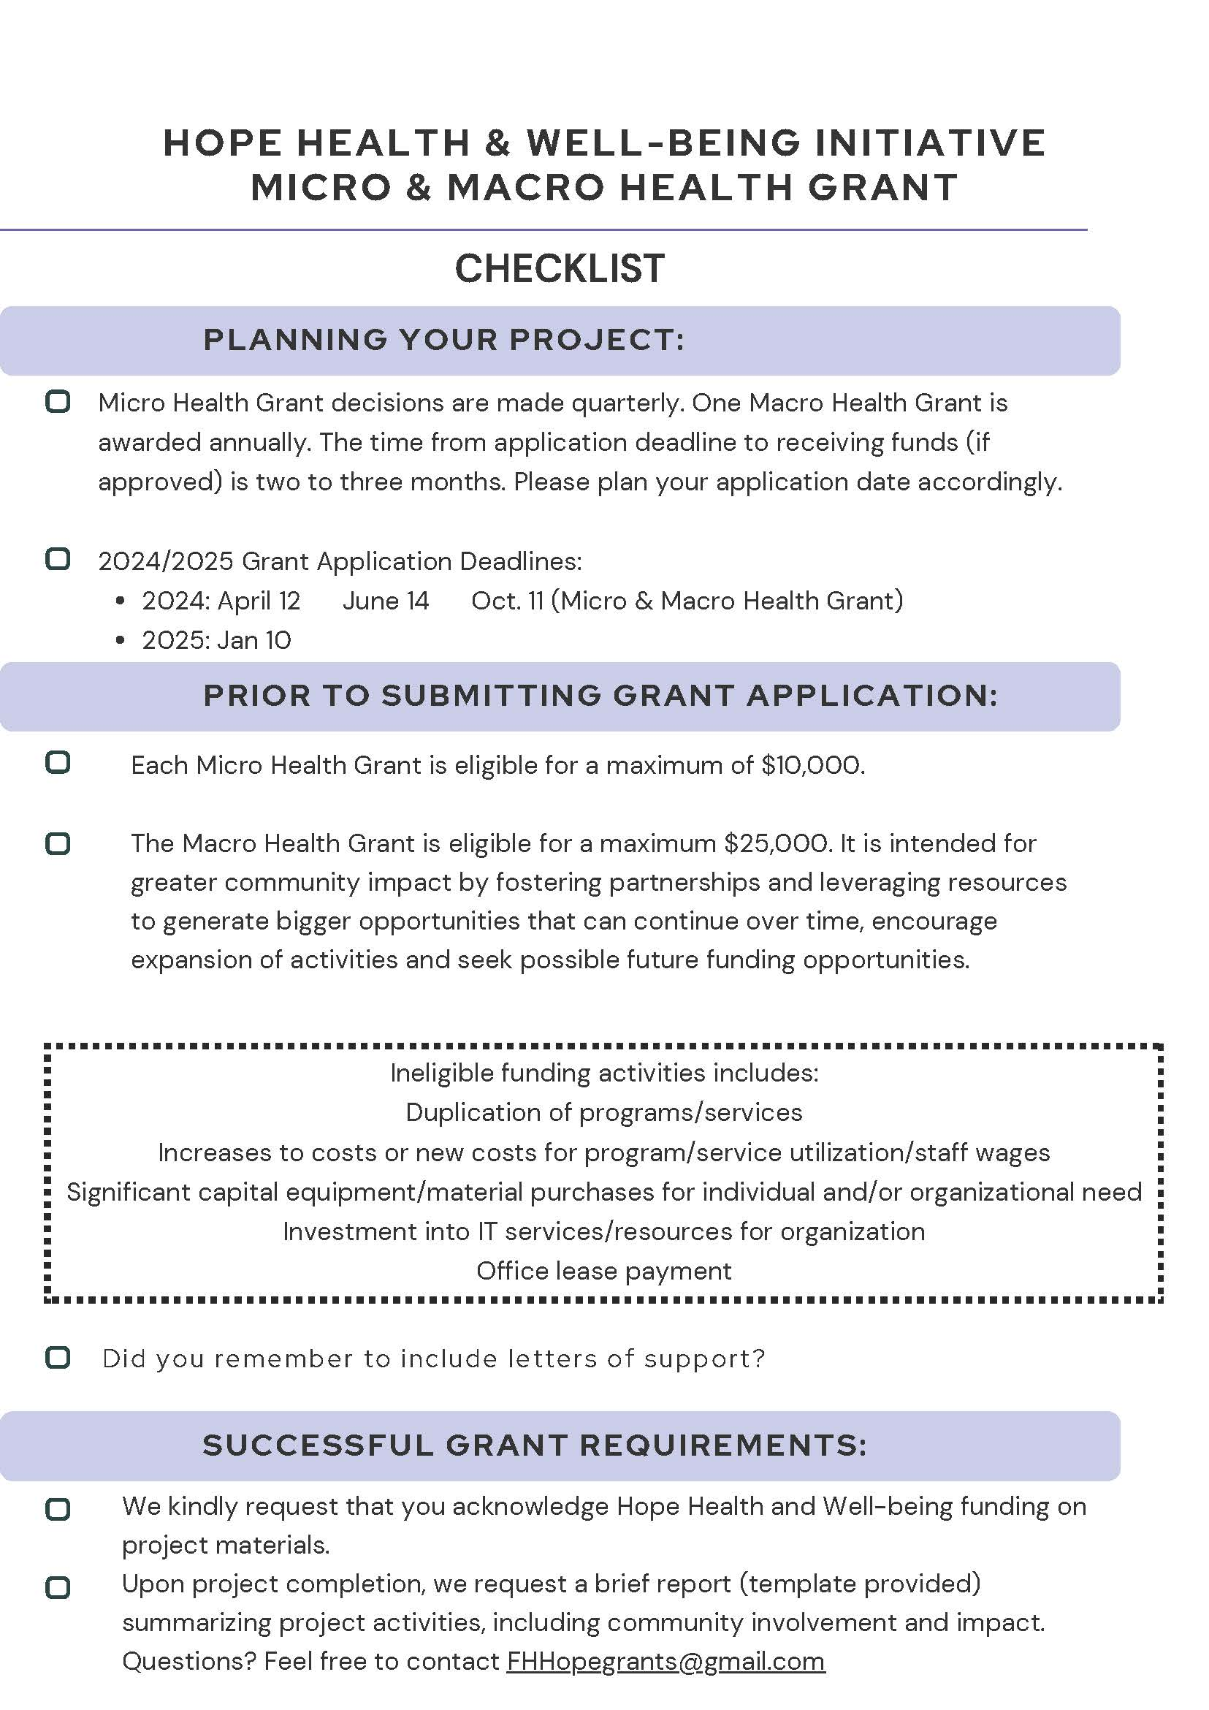
3.0 Application

Part A: Applicant Information

Micro Health Grant Title: |  | Organization Name:
Applicant Name/Position: |  | Mailing Address/Telephone/E-mail:
Total Requested: $ | Target Audience: |  | Estimated Number Reached:
Project Description & Objectives: (limit 250 words)
Confirmed Partners: Please list confirmed community
Intended Outcomes, Measurables & Impact:
Budget Allocation: Provide a budget itemized by broad category (ie supplies, equipment, honorariums, travel, etc.) with rationale
Sustainability Plan:
Applicant Commitment: Describe the Applicant’s financial commitment (cash and/or in-kind) to the Project
Please note: If this application is successful, the Hope Health and Well-being Initiative will periodically connect to offer support, collaborate on addressing potential challenges, and understand progress and outcomes to highlight in the community. Upon completion, we request a brief report summarizing these activities, including the community involvement and impact, using the reporting template we provide.

For grant review purposes only:
- Achievability □ Sustainability □ Affordability
- Partnership □ Measurability □ Accessibility/Health Equity
- Impact □ Social Change □ Safety

