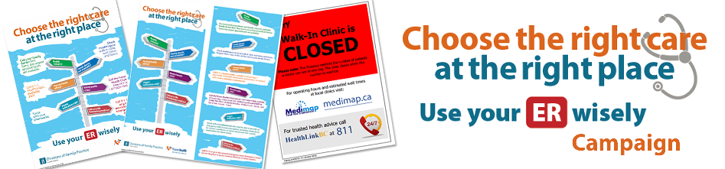
- What are we doing?
The [Enter your district] Division of Family Practice, in collaboration with Fraser Health, has launched a public education campaign about health care options available to patients in order for them to “Choose the right care at the right place/Use your ER wisely”.
- Why are we doing this?
To strengthen the connection between patients and primary care providers and maximize the use of community-based services, thereby reducing the reliance on the hospital for non-urgent emergency care.
- How can your Clinic help?
- Display the “Choose the right care at the right place/Use your ER wisely” poster in each of your exam rooms (11”x17”), and in your waiting area (18”x24”).
- Distribute the “Choose the right care at the right place/Use your ER wisely” rack card (4”x9”) to patients. The rack card has additional information to the poster.
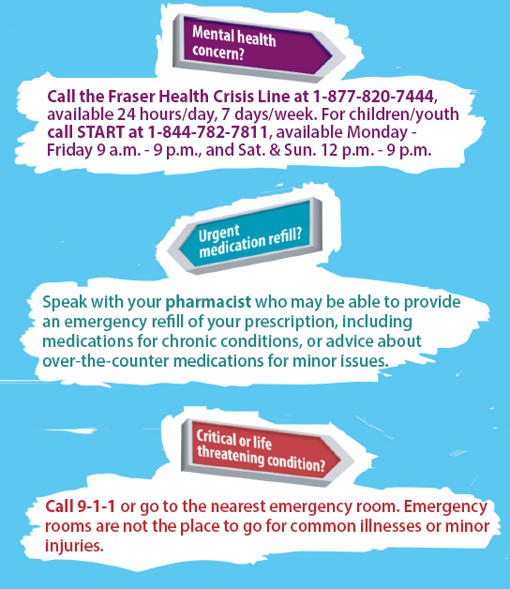
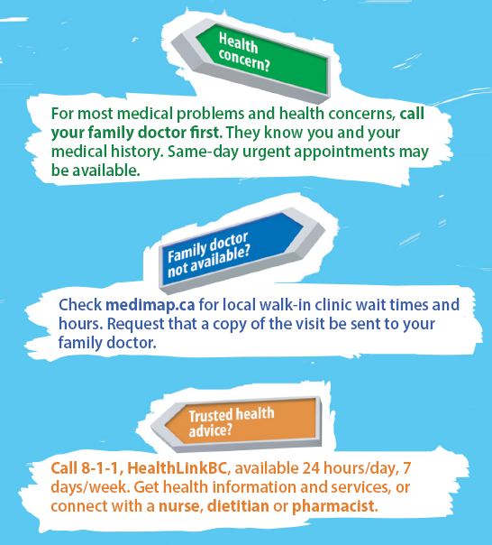
- Please ensure that all your clinic providers and staff are aware of the campaign’s key messages (as per back of rack card below):

- Verbally reinforce these key messages with your patients to empower them to make informed choices and promote the use of appropriate sources of care.
- A recent survey indicated that all family practice clinics have a process for accommodating same day urgent appointments. Please ensure that clinic staff are consistent in explaining your process to patients when they inquire about same day urgent access.
- For Family Practice and Walk-In Clinics, update your after-hours voicemail message to include:
You have reached the XXX clinic, we are now closed.
For trusted health advice call 8-1-1, Healthlink BC is available 24/7.
Check medimap.ca for local walk-in clinic wait times and hours.

Please Note - Any caller to 8-1-1 first receives an automated message prior to answering by HealthLink BC navigation services as follows:
"Welcome to HealthLink BC. If you require any emergency service, or someone in your care has chest pains, difficulty breathing or severe bleeding please call 911 now or the emergency number in your phonebook. If this call is about a possible poisoning or exposure to a toxic substance, call poison control now at 1-800-567-8911. Please note that calls are recorded for quality training purposes........"

- For Walk-In Clinics, update your automated message during business hours to include:
Before your next visit to the walk-in clinic, please check medimap.ca for estimated wait times and hours.

- Who to contact for further information?
[Enter your contact information] Thank you for your participation and support!
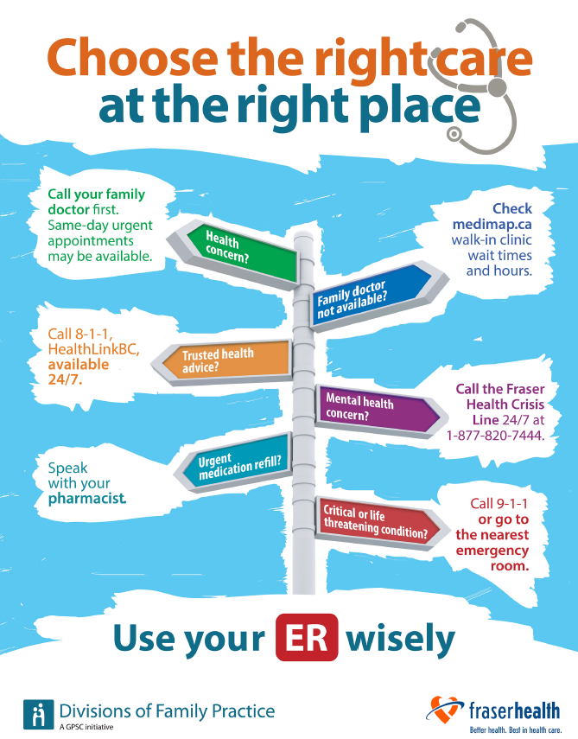
Poster:

