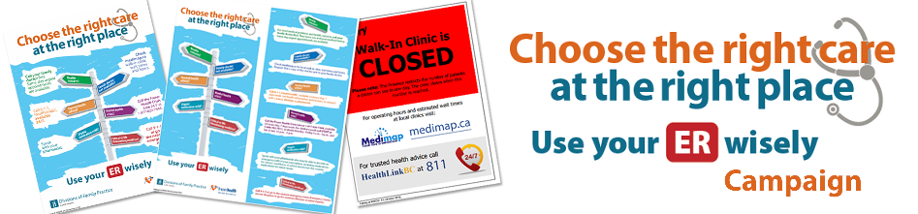
- What are we doing?
The [Enter your district] Division of Family Practice, in collaboration with Fraser Health, has launched a public education campaign about health care options available to patients in order for them to to “Choose the right care at the right place/Use your ER wisely”.
- Why are we doing this?
To strengthen the connection between patients and primary care providers and maximize the use of community-based services, thereby reducing the reliance on the hospital for non-urgent emergency care.
- How can you help?
- Display the to “Choose the right care at the right place/Use your ER wisely” poster in (11”x17”) in key locations.
- Distribute the “Choose the right care at the right place/Use your ER wisely” rack cards (4”x9”).
- Please ensure that your staff are aware of the campaign’s key messages (as per back of rack card below):
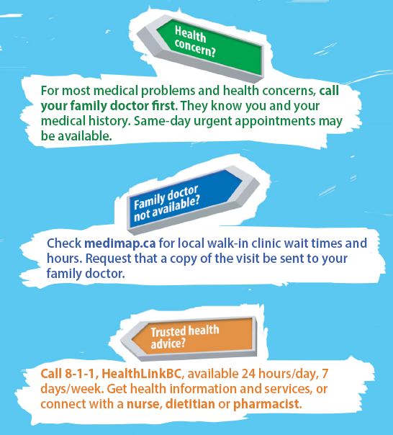 | 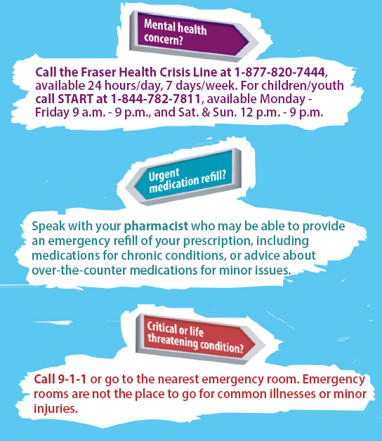

- Verbally reinforce these key messages with the public to empower them to make informed choices and promote the use of appropriate sources of care.
- A recent survey indicated that local family practice clinics have a process for accommodating same day urgent appointments.
- Who to contact for further information?
[Enter your contact information]
Thank you for your participation and support!
Poster:
