Keeping You Informed | [Enter Hospital Name]
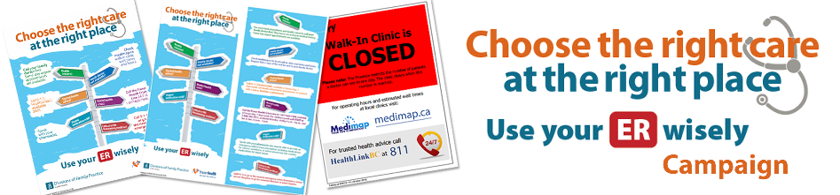
What’s Happening?
- The [Enter your district] Division of Family Practice, in collaboration with Fraser Health, has launched a public education campaign about health care options available to patients in order for them to “Choose the right care at the right place/Use your ER wisely”.
- Why are we doing this? To strengthen the connection between patients and primary care providers and maximize the use of community-based services, thereby reducing the reliance on the hospital for non-urgent emergency care.
How This May Affect You? You can all help by doing the following:
- Display the “Choose the right care at the right place/Use your ER wisely” poster (11”x17” and 18”x24”) in key locations.
- Distribute the “Choose the right care at the right place/Use your ER wisely” rack card (4”x9”) to patients.
- Please ensure that all your staff are aware of the campaign’s key messages (as per back of rack card below):
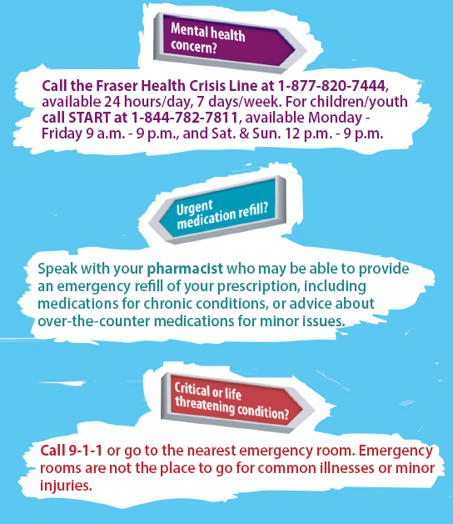
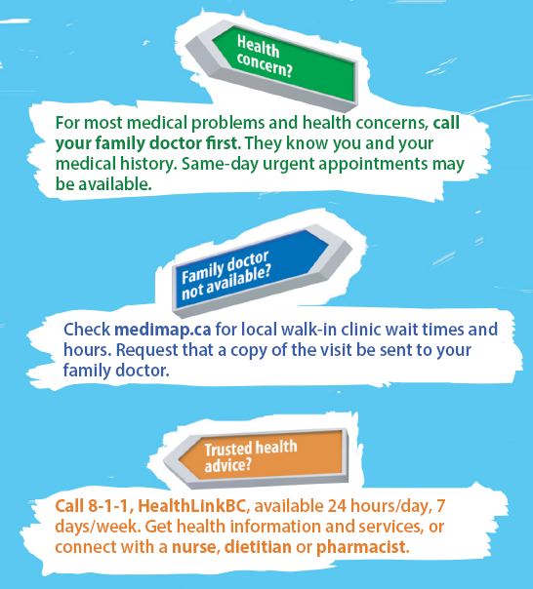

- Verbally reinforce these key messages with your patients to empower them to make informed choices and promote the use of appropriate sources of care.
- A recent survey indicated that local family practice clinics have a process for accommodating same day urgent appointments.
Who to contact for further information?
[Enter your contact information]
Poster
