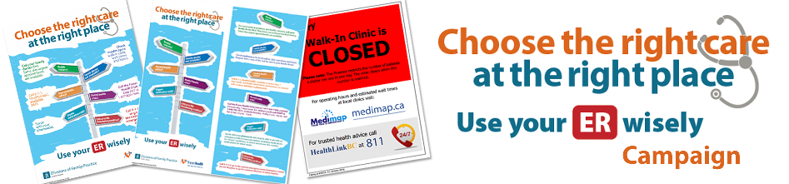

Fraser Health Emergency Network Roles and Responsibilities

- Collaborate with Divisions, hospitals, Practice Support Programs (PSP) and Communications to spread this campaign.
- Ensure branding of the campaign (Choose the Right Care at the Right Place / Use your ER wisely) remains consistent in order to ensure maximum effectiveness of the message with all the public.
- Medical Director to act as media spokesman if required, in collaboration with local Division lead.

Examples of Campaign Materials
Note: Posters and rack cards are currently being translated into Chinese Simplified and Punjabi. They will be posted to fraserhealth.ca and available to order once translation has been completed.

Posters | Rack Cards | Closed Sign
Sizes available:  8.5” x 11”  11” x 17”  18” x 24” | Sizes available:  4” x 9” | Sizes available:  8.5” x 11”
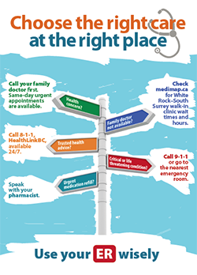 | 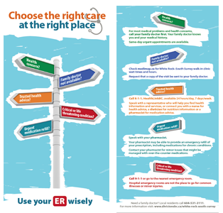 | 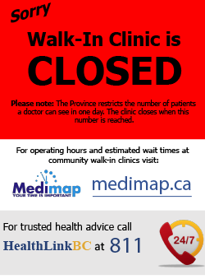

Order Form
We request that the Division and hospital collaborate on one bulk order. To streamline the process, the Division’s order should include posters required by all GPs and walk-in clinics.

Copy the table below, paste into an email, and add your quantities. Email to feedback@fraserhealth.ca.
Fraser Health will print the posters and rack cards at no cost and deliver to the addresses you provide below. Allow about 4-5 weeks for delivery.

Division of Family Practice Order Information
Name: |  |  | Email Address:
Phone No: |  |  | Title:
Delivery/Shipping Address:
Hospital Order Information
Name: |  |  | Email Address:
Phone No: |  |  | Title:
Delivery/Shipping Address:
Item |  | Division of Family Practice |  | Hospital
8.5"x11" Poster
11"x17" Poster
18"x24" Poster
4”x9” Rack cards

Closed signs for walk-ins

Sample Order
To guide you, here is what the White Rock South Surrey Division and Peace Arch Hospital ordered at the outset.

Item | White Rock South Surrey Division | Peace Arch Hospital
8.5"x11" Poster | -- | 10 Peace Arch Hospital elevator notice boards
11"x17" Poster | 120 for Clinic exam rooms  29 for City of White Rock | 1 Admin Reception Area  20 for Peace Arch Hospital units
18"x24" Poster | 19 for Clinic waiting room areas  6 for City of White Rock | --
4”x9” Rack cards | 2500  Clinics  Libraries  City of White Rock  (rec centres)  Innovation Fitness  Seniors Come Share  Pharmacies | 500  Peace Arch Hospital  Peace Arch Hospital Foundation

