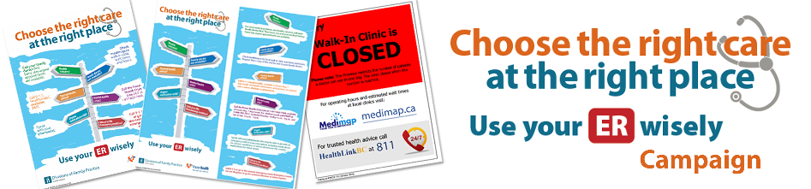

Walk-in Clinic Roles and Responsibilities

- Commit to support the campaign.
- Launch medimap.ca if not already participating.
- Adopt after-hours voice message to reflect 8-1-1 option and medimap.ca.
- Adopt automated message during business hours to include medimap.ca.
- Display posters in waiting room and each exam room.
- Display rack cards in waiting room.
- Display consistent Closed signage on front door outlining options for patients after hours.
- Customize/use Clinic Campaign Guide to promote staff awareness of key messages.
- Consider adding video or your poster PDF to electronic signage if it exists in the clinic.
- Reinforce key messages with patients.
- Monitor supply of rack cards and re-order via Fraser Health at feedback@fraserhealth.ca when necessary.

Examples of Campaign Materials
Note: Posters and rack cards are currently being translated into Chinese Simplified and Punjabi. They will be posted to fraserhealth.ca and available to order once translation has been completed.

Posters | Rack Cards | Closed Sign
Sizes available:  8.5” x 11”  11” x 17”  18” x 24” | Sizes available:  4” x 9” | Sizes available:  8.5” x 11”
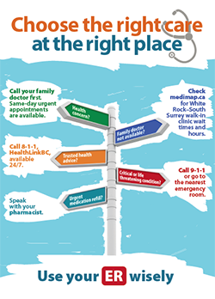 | 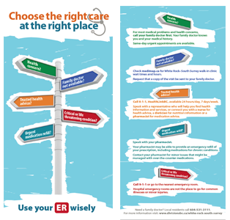 | 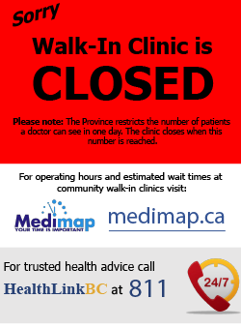

Order Form
We request that the Division and hospital collaborate on one bulk order. To streamline the process, the Division’s order should include posters required by all GPs and walk-in clinics.

Copy the table below, paste into an email, and add your quantities. Email to feedback@fraserhealth.ca.
Fraser Health will print the posters and rack cards at no cost and deliver to the addresses you provide below. Allow about 4-5 weeks for delivery.

Division of Family Practice Order Information
Name: |  |  | Email Address:
Phone No: |  |  | Title:
Delivery/Shipping Address:
Hospital Order Information
Name: |  |  | Email Address:
Phone No: |  |  | Title:
Delivery/Shipping Address:
Item |  | Division of Family Practice |  | Hospital
8.5"x11" Poster
11"x17" Poster
18"x24" Poster
4”x9” Rack cards

Closed signs for walk-ins

Sample Order
To guide you, here is what the White Rock South Surrey Division and Peace Arch Hospital ordered at the outset.

Item | White Rock South Surrey Division | Peace Arch Hospital
8.5"x11" Poster | -- | 10 Peace Arch Hospital elevator notice boards
11"x17" Poster | 120 for Clinic exam rooms  29 for City of White Rock | 1 Admin Reception Area  20 for Peace Arch Hospital units
18"x24" Poster | 19 for Clinic waiting room areas  6 for City of White Rock | --
4”x9” Rack cards | 2500  Clinics  Libraries  City of White Rock  (rec centres)  Innovation Fitness  Seniors Come Share  Pharmacies | 500  Peace Arch Hospital  Peace Arch Hospital Foundation

