Omnicell User Access Information –
Students and Instructors

Site Contacts:

SITE | E-mail mailbox | Clinical Nurse Advisor (CNA)
Royal Columbian Hospital | RCHAMDS@fraserhealth.ca | Kelly.Riley@fraserhealth.ca  Cell: 604-613-8294
Chilliwack General Hospital  Fraser Canyon Hospital | CGHAMDS@fraserhealth.ca | Martina.Klassen@fraserhealth.ca  Cell: 604-316-5209  Fax: 1-604-795-4135

General Information:

- Faculty and preceptor students placed at an Omnicell site will require basic Omnicell training and Bio ID registration onto the system.

- Clinical students placed at an Omnicell site must complete an online Omnicell module through Learning Hub prior to Bio ID registration onto the system.

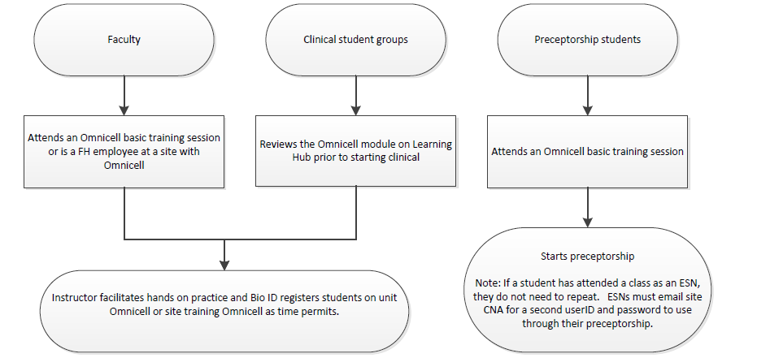

- At least 14 days prior to the start of the placement, the school coordinator/representative must e-mail/fax a completed user access request form to the specific site e-mail mailbox or CNA
Note: - User access request forms are not accepted directly from a student

- Students/faculty will only be given access to the Omnicell on the unit(s) requested/approved on the user access request form as per the dates on the access request form.
Note: The site CNA must be informed of any changes to the requested unit(s), dates and for any placement cancellations.

- Contact the site CNA to update usernames, passwords, or access.
- Students/faculty will use Biometric identification [finger scanning] after an initial password has been assigned.

- Students must review the FH Automated Dispensing Cabinet (ADC) policies and be aware of the FH policy Confidentiality and Security of Personal Information.

- Access will start on the first day of the assignment and will end after the last shift of the assignment to ensure system security.

- Students (Clinical, preceptors) will not have access to remove narcotics, benzodiazepines or controlled substances.
Exception: Specialty Education nurses [Post Licensure Students]

- All narcotic, controlled drugs, insulin and anticoagulant removals/administration must be supervised and co-signed by the instructor/RN/LPN/RPN as per current practice. Co-signature occurs on the MAR/Chart.
Exception: RNs in specialty education courses.

- All Narcotic/controlled drug wastage must be documented. A student may act as the witness for doses they have prepared. Two students cannot witness wastage together.

- Instructors must ensure that any narcotic/controlled substance discrepancies that occur during Omnicell transactions, involving a student, must be resolved and documented prior to leaving at shift end.

Faculty Access:

- Clinical Instructors (for onsite clinical sessions) must attend an Omnicell basic training class prior to being given access privileges and before their first clinical assignment to ensure they are prepared to support the clinical group.
- Instructors who are FH employees who work at an Omnicell facility can use their FH access username/login

- Bio ID/password registration will occur during the training session.

- For subsequent site sessions, the instructor will use the same personal username, Bio ID and password.

- Clinical instructors will Bio ID register student groups on the units or at the training cabinet.

- Faculty members will have full RN/LPN/RPN access.

- Faculty user names will be prefixed with F-

- The instructor must remove/return/waste narcotics, benzodiazepines, controlled drugs and override medications for the student and ensure that any student narcotic discrepancies are resolved and documented prior to the student(s) leaving at shift end.

Clinical Student Groups:

- Students must complete the Omnicell module on Learning Hub prior to starting the clinical. This will be the responsibility of the school.

- Bio ID activation can occur on the training cabinet or on any unit Omnicell as time allows.

- Student user names will be prefixed with S-

- Clinical students will not access the override feature. Faculty will need to remove any pharmacy verification required (PVR) medications required by their students.

Preceptorship Students:

- Preceptorship students must attend a basic Omnicell training session.
Exception: Students, who have already attended an Omnicell training session as an ESN, do not need to repeat the class. These students must contact the site CNA to set up a separate preceptorship user ID and password.

- Students who have used Omnicell previously during a group clinical practicum (i.e. clinical instructor supervision) must still attend a full Omnicell basic training session.

- Bio ID/password registration will occur during the training session.

- Preceptorship students usernames will be prefixed with P-

- Student preceptees can access override under direct regulatory supervision. All transaction documentation requires a co-signature.

- Preceptors will need to remove any pharmacy verification required (PVR) medications required by their students.

Resources:

- Basic Omnicell Training Schedule and course registration available on Learning Hub for faculty and preceptor students.

- Omnicell online learning module available through Learning Hub for clinical students.
Course title: ADC – Omnicell Patient Care in a Profiled Environment

- Quick guide brochure

- An Omnicell training cabinet is available on site. Contact the site CNA to book access

- Schools can request electronic copies of the FH ADC policies

